LODGE 66

T – Shirt Sales  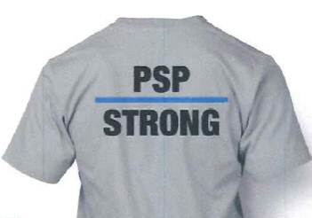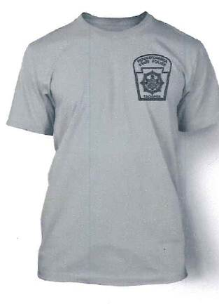 | Lodge 66 Sale:  Saturday, December 6, 2PM – 4PM  West Bradford Fire Co. Sub-Station  1387 Campus Drive, Downingtown, PA 19335
$15 for adult sizes and $12 for youth and kids. Cash only

Limited amount of merchandise available. First come first served.

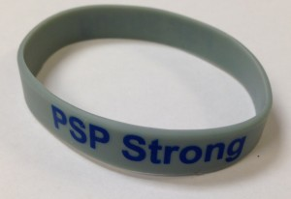  PSP Strong Wristbands will be available for $3.00 each. | 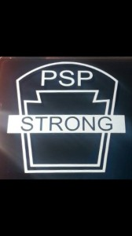  PSP Strong Car Decals will be available for $5.00 each. They come in Blue and Gray.
WHO BENEFITS FROM SHIRT SALES:
100% of the proceeds from the sale of the PSP Strong t-shirts are being donated to the victims of the September 12 PSP Blooming Grove Ambush.

